

Semester Two Examination, 2016

Question/Answer Booklet

MATHEMATICS

SOLUTIONS
APPLICATIONS
UNITS 1 AND 2

Section Two:

Calculator-assumed

Student Number: In figures

In words

Your name

Time allowed for this section
Reading time before commencing work: ten minutes
Working time for section: one hundred minutes

Materials required/recommended for this section
To be provided by the supervisor
This Question/Answer Booklet
Formula Sheet (retained from Section One)

To be provided by the candidate
Standard items: pens (blue/black preferred), pencils (including coloured), sharpener, correction fluid/tape, eraser, ruler, highlighters

Special items: drawing instruments, templates, notes on two unfolded sheets of A4 paper, and up to three calculators approved for use in the WACE examinations

Important note to candidates
No other items may be taken into the examination room. It is your responsibility to ensure that you do not have any unauthorised notes or other items of a non-personal nature in the examination room. If you have any unauthorised material with you, hand it to the supervisor before reading any further.

Structure of this paper

Section | Number of questions available | Number of questions to be answered | Working  time (minutes) | Marks available | Percentage of exam
Section One:  Calculator-free | 7 | 7 | 50 | 51 | 35
Section Two:  Calculator-assumed | 13 | 13 | 100 | 99 | 65
 |  |  | Total | 150 | 100

Instructions to candidates

1. The rules for the conduct of examinations are detailed in the school handbook. Sitting this examination implies that you agree to abide by these rules.

2. Write your answers in this Question/Answer Booklet.

3. You must be careful to confine your response to the specific question asked and to follow any instructions that are specified to a particular question.

4. Spare pages are included at the end of this booklet. They can be used for planning your responses and/or as additional space if required to continue an answer.
- Planning: If you use the spare pages for planning, indicate this clearly at the top of the page.
- Continuing an answer: If you need to use the space to continue an answer, indicate in the original answer space where the answer is continued, i.e. give the page number. Fill in the number of the question that you are continuing to answer at the top of the page.

5. Show all your working clearly. Your working should be in sufficient detail to allow your answers to be checked readily and for marks to be awarded for reasoning. Incorrect answers given without supporting reasoning cannot be allocated any marks. For any question or part question worth more than two marks, valid working or justification is required to receive full marks. If you repeat any question, ensure that you cancel the answer you do not wish to have marked.

6. It is recommended that you do not use pencil, except in diagrams.

7. The Formula Sheet is not to be handed in with your Question/Booklet.

Section Two: Calculator-assumed 65% (99 Marks)
This section has thirteen (13) questions. Answer all questions. Write your answers in the spaces provided.

Working time for this section is 100 minutes.

Question 8 (6 marks)
A worker in a chemical factory earns $42.70 per hour on a weekday, time and a half at weekends, and a fixed allowance of $39.15 per day.

(a) Calculate the workers' weekly pay when she works from 9 am until 1 pm and then 1.30 pm until 4.30 pm from Wednesday to Sunday inclusive. (4 marks)
Solution
Daily hours: $4+3=7$ hours per day
Weekdays: $42.70×7+39.15=338.05$ per day
Weekends: $42.70×1.5×7+39.15=487.50$ per day
Total: $3×338.05+2×487.50=1014.15+975.00=\$1989.15$ per week

Specific behaviours
calculates daily hours
calculates weekday pay
calculates weekend pay
calculates total pay

(b) Calculate the workers' total holiday pay when she takes four weeks leave, if the company pays her for 35 hours per week at her base rate, does not pay the fixed allowance but does add leave loading of 17.5%. (2 marks)
Solution
Weekly: $4×42.70×35×1.175=5978×1.175=\$7024.15$

Specific behaviours
calculates 4 wks at base rate
increases by 17.5%

Question 9 (8 marks)
Sam and Tom recorded their daily exercise time over a two-week period. Their times are shown below to the nearest minute.
Sam | 29 | 27 | 30 | 28 | 27 | 28 | 31 | 31 | 25 | 32 | 26 | 27 | 32 | 26
Tom | 27 | 24 | 25 | 26 | 27 | 23 | 28 | 26 | 29 | 25 | 27 | 29 | 26 | 29

(a) The left-hand side of the stem plot below displays the exercise times for Sam. Complete the right-hand side for the times that Tom exercised. (2 marks)

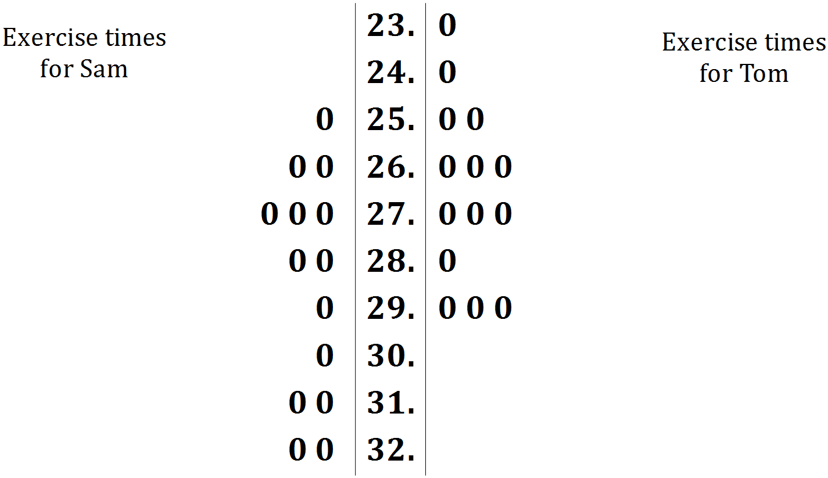
Solution
See stem plot
Specific behaviours
plots 14 zeroes
aligns zeroes in vertical columns

(b) Calculate the mean of the times spent exercising for each person and explain how their difference relates to a feature of the stem plot. (3 marks)
Solution
${\overline{x}}_{SAM}=28.5$ and ${\overline{x}}_{TOM}=26.5$ minutes

The leaves for Sam (LHS) are clearly further down the scale than the leaves for Tom (RHS).

Specific behaviours
calculates first mean
calculates second mean
explains difference using feature of stem plot

(c) Calculate the standard deviations of the times spent exercising for each person and explain how their difference relates to a feature of the stem plot. (3 marks)
Solution
$sd_{SAM}=2.26$ and $sd_{TOM}=1.80$ minutes

The leaves for Sam (LHS) are more spread out than for Tom (RHS)

Specific behaviours
states first standard deviation
states second standard deviation
explains difference using feature of stem plot

Question 10 (6 marks)
A semi-circular grassed area has a radius of 45 m.

(a) A fence is to be installed around the edge of the area at a cost of $85 per metre. Calculate the cost of fencing to the nearest hundred dollars. (3 marks)
Solution
Curved length: $2×π×45÷2=141.4$ m

Total: $2×45+141.4=231.4$ m

Cost: $231.4×85=19669≈\$19 700$

Specific behaviours
calculates curved side
calculates total length
calculates cost, rounding to nearest $100

(b) A rotunda is to be built in the middle of the grassed area with a hemispherical glass roof. The cost of the rotunda is $17 800 plus $235 per square metre for the glass used in the hemispherical roof. If the radius of the hemisphere is 4.5 m, calculate the cost of building the rotunda to the nearest hundred dollars. (3 marks)
Solution
Area of glass: $4×π×{4.5}^{2}÷2=127.2$ m²

Cost: $17800+127.2×235=17800+29892=47692≈\$47 700$

Specific behaviours
uses sphere area formula
adjusts for hemisphere
calculates total cost, rounding to nearest $100

Question 11 (7 marks)
A young couple purchased a house for $419 000 and sold it one year later for $432 000.

(a) Calculate the percentage profit they made. (2 marks)
Solution
$Profit=432000-419000=13000$

$\frac{13000}{419000}×100=3.1\%$ profit

Specific behaviours
calculates profit
calculates percentage profit

(b) The couple financed their purchase of the house with an interest only loan of $336 000 at a rate of 4.85% pa. Calculate the simple interest payable for the first month. (2 marks)
Solution
$I=336000×0.0485×\frac{1}{12}=16296×\frac{1}{12}=\$1358$

Specific behaviours
calculates interest for one year
calculates interest for one month

(c) The couple used the services of a real estate agent to sell the house. The agent charged 2.5% of the selling price on the first $100 000 and 0.75% on the remainder. Calculate the agent's fee for selling the house. (2 marks)
Solution
$0.025×100000+0.0075×332000=2500+2490=\$4990$

Specific behaviours
splits selling price correctly
works out percentages and adds

(d) The agent bought advertising through an internet company for $423.50, including GST at 10%. How much of the advertising cost was GST? (1 mark)
Solution
$GST=\frac{423.50}{11}=\$38.50$

Specific behaviours
calculates GST

Question 12 (7 marks)
Stalls at a pop-up market cost $60 per day. A student, who makes pairs of earrings that cost $5 each and sell for $11 each, hires a stall for a day.

(a) If the student sells $x$ pairs of earrings at the market one day, explain why

(i) the total cost for the day is given by $5x+60$. (1 mark)
Solution
Cost is sum of making earrings ($5x$) and stall hire ($60$)
Specific behaviours
identifies parts of expression

(ii) the total revenue for the day is given by $11x$. (1 mark)
Solution
Revenue is number sold ($x$) multiplied by price ($11)$
Specific behaviours
reasonable explanation

(b) Complete the table below to show the cost and revenue for the given values of $x$.
(2 marks)
Solution
See table
Specific behaviours
all costs
all revenues

$$x$$ | 0 | 6 | 12 | 18
Total cost, $ | 60 | 90 | 120 | 150
Total revenue, $ | 0 | 66 | 132 | 198

(c) Graph the two straight lines that represent the daily cost and revenue when the student sells $x$ pairs of earrings at the market on the axes below. (2 marks)

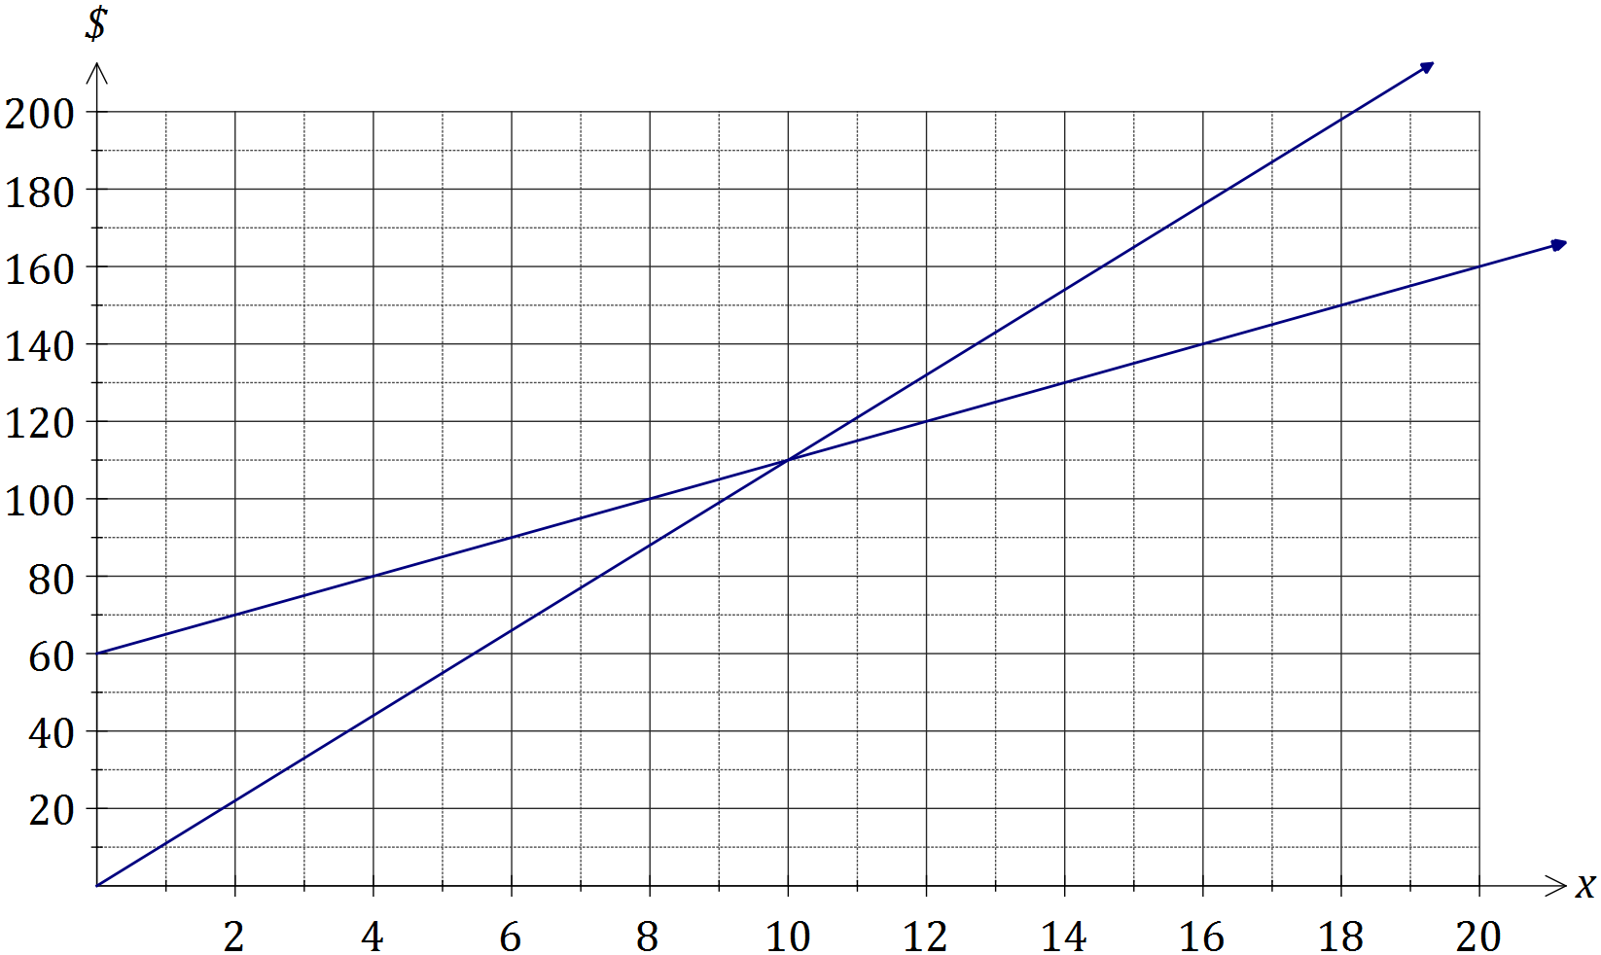
Solution
See graph
Specific behaviours
straight line for cost
straight line for revenue

(d) Using your graph, or otherwise, determine the number of pairs of earrings that the student must sell per day in order to break-even at the market. (1 mark)
Solution
10 pairs of earrings
Specific behaviours
states $x$ value that reflects intersection of lines

Question 13 (8 marks)
(a) A young person working in a grocery store has to label shelves with the price per 100 mL of the following bottles of detergent made by the same company:

- a small 450 mL bottle priced at $1.69
- a medium 720 mL bottle priced at $2.99
- a large 1.25 L bottle priced at $4.95

(i) Determine the unit cost for each bottle as required by the store and hence state which size represents the best value. (3 marks)
Solution
Small: $169×\frac{100}{450}=37.6$ c/100mL
Medium: $299×\frac{100}{720}=41.5$ c/100mL

Large: $495×\frac{100}{1250}=39.6$ c/100mL

Small is the best value.

Specific behaviours
calculates 100 mL costs for small and medium
calculates 100 mL cost for large
selects best value

(ii) The company that made the detergent had just increased the wholesale price of a box of 24 small bottles from $26.40 to $27.30, claiming that the increase was below the current 2.4% annual rate of inflation. Was this claim correct? Justify your answer. (2 marks)
Solution
Increase is $\frac{0.9}{26.40}×100=3.4\%$
Claim incorrect, as increase of 3.4% was above inflation rate of 2.4%.

Specific behaviours
states claim incorrect, with reason
justifies mathematically

(b) A sum of $5 500 was invested for four years in an account paying 3.75% interest per annum compounded annually.

(i) Calculate the amount in the account at the end of the four years. (2 marks)
Solution
$FV=5500×{1.0375}^{4}=\$6372.58$

Specific behaviours
substitutes into compound interest formula
calculates future value

(ii) Determine the total interest accumulated over the four years. (1 mark)
Solution
Interest: $6372.58-5500.00=\$872.58$

Specific behaviours
calculates interest

Question 14 (7 marks)
A triangular sign has sides of lengths 1.2 m, 1.5 m and 1.8 m.

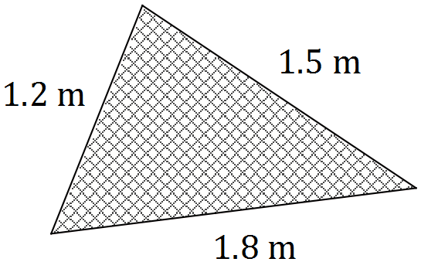

(a) Use Heron's rule to determine the area of the sign. (3 marks)
Solution
$s=\frac{1.2+1.5+1.8}{2}=2.25$
$A=\sqrt{2.25\left(2.25-1.2\right)\left(2.25-1.5\right)\left(2.25-1.8\right)}≈0.893$ sq m

Specific behaviours
calculates semi-perimeter
substitutes into Heron's rule
calculates area, rounding sensibly

(b) Show use of trigonometry to determine the size of the angle opposite the side of length 1.8 m. (2 marks)
Solution
${1.8}^{2}={1.2}^{2}+{1.5}^{2}-2×1.2×1.5×\cos{A}$

$A=82.8°$

Specific behaviours
substitutes correctly into cosine rule
calculates angle

(c) Use trigonometry to determine the size of the smallest angle in the triangle. (2 marks)
Solution
$\frac{1.2}{\sin{A}}=\frac{1.8}{\sin{82.8}}$

$A=41.4°$

Specific behaviours
shows use of trig
calculates smallest angle

Question 15 (8 marks)
Nasim won $12 500 in a lottery and decided to invest $7 000 in the stock market and spend the rest on a holiday.

(a) Nasim booked a holiday in Egypt, converting $750 Australian dollars (AUD) spending money into Egyptian pounds (EGP) before he left. The exchange rates advertised by his local bank for 1 AUD to EGP were buy: 7.5768 and sell: 5.7723.

(i) Calculate how many Egyptian pounds Nasim took with him, giving your answer to the nearest 10 pounds. (3 marks)
Solution
$750×5.7723=4329.23≈4330$ Egyptian pounds

Specific behaviours
uses sell rate
multiplies to convert
rounds to nearest 10 pounds

(ii) Nasim returned from holiday with 950 Egyptian pounds. How many Australian dollars would his local bank give him for these pounds? (2 marks)
Solution
$950÷7.5768=\$125.38$

Specific behaviours
uses buy rate
divides to convert

(b) The cost of the shares Nasim bought at $11.55 each in a company, together with his brokerage fee of $70, came to exactly $7 000. The company forecast it would pay a full year dividend of 35 cents per share.

(i) Determine how many shares Nasim bought in the company. (2 marks)
Solution
$7000-70=6930$
$6930÷11.55=600$ shares

Specific behaviours
calculates amount spent on shares
calculates number of shares

(ii) What is his expected full year dividend payment? (1 mark)
Solution
$600×0.35=\$210$

Specific behaviours
multiplies number of shares by dividend, showing units

Question 16 (8 marks)
A solid cone has a base radius of 8 cm and a slant height of 17 cm.

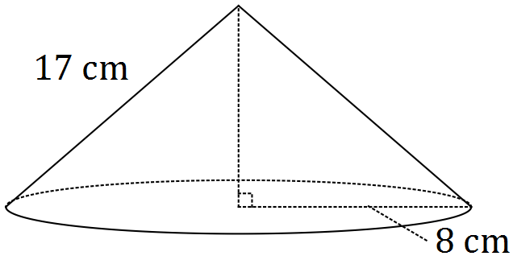

(a) Determine the total surface area of the cone. (2 marks)
Solution
$TSA=π×8^{2}+π×8×17$
$TSA=628.3$ cm²

Specific behaviours
substitutes into formula
evaluates TSA

(b) Calculate the perpendicular height of the cone. (2 marks)
Solution
$$h^{2}+8^{2}={17}^{2} \\ h=15$$

Specific behaviours
uses Pythagoras
calculates height

The solid cone is placed inside an empty cylindrical vase of diameter 16 cm and height 18 cm.
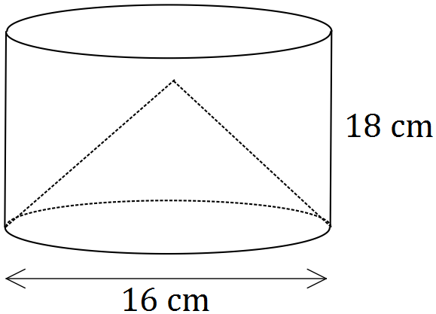

(c) Water is then poured into the vase until it reaches the top. Assuming that the cone does not float, how much water will be required to fill the vase? (4 marks)
Solution
$V_{cone}=\frac{1}{3}×π×8^{2}×15=1005$
Cylinder radius $=\frac{16}{2}=8$
$V_{cyl}=π×8^{2}×18=3619$
$V=3619-1005=2614$ cm³

Specific behaviours
calculates volume of cone
uses correct cylinder radius
calculates volume of cylinder
subtracts to find volume of water

Question 17 (11 marks)
An energy saving globe costs $12 to buy and $0.005 per hour to run. A regular globe that delivers the same amount of light as the energy saving globe costs $2.50 to buy and $0.03 per hour to run.

(a) Assuming that neither globe will need to be replaced,

(i) explain why the cost, in dollars, of buying and running one energy saving globe for $x$ hours is given by the expression $12+0.005x$. (1 mark)
Solution
12 = cost of globe, plus 0.005 multiplied by number of hours run

Specific behaviours
reasonable explanation of both parts of expression

(ii) write an expression for the cost, in dollars, of buying and running one regular globe for $x$ hours. (1 mark)
Solution
$2.5+0.03x$

Specific behaviours
correct expression

(iii) determine the number of hours for which the cost of buying and running the globes is the same. (2 marks)
Solution
Solve $12+0.005x=2.5+0.03x$ to get $x=380$ hours

Specific behaviours
writes equation
solves equation

(b) It is expected that the regular globe will require replacing every 500 hours.

(i) Complete the table below to show the total cost of buying a regular globe and replacements, and running them for the hours shown. (3 marks)

Hours of running time ($x$) | 0 | 250 | 500 | 750 | 1000
Cost of globe, in dollars | 2.50 | - | 2.50 | - | 2.50
Running cost, in dollars | 0 | 7.50 | 15.00 | 22.50 | 30.00
Total cost in dollars ($C$) | 2.50 | 10.00 | 20.00 | 27.50 | 37.50
Solution
See table
Specific behaviours
running costs
total costs

(ii) Plot the total cost of buying a regular globe and replacements, and running them for up to 1 500 hours, on the axes below. (4 marks)

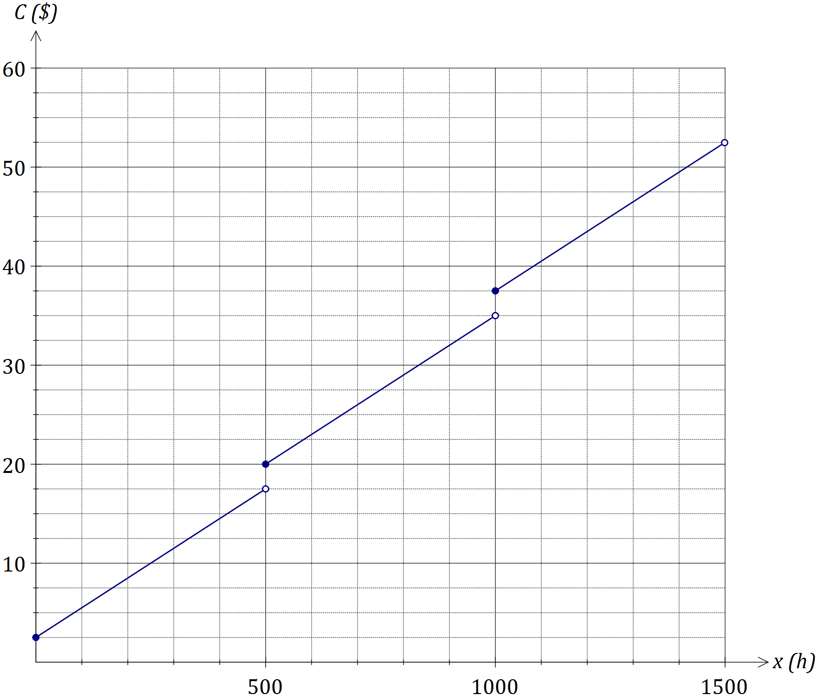

Solution
See graph
Specific behaviours
plots five points from table in (b)(i)
attempt at piecewise graph
all three pieces correct
correct markers at end of each piece

Question 18 (8 marks)
(a) The speeds of cars travelling along a stretch of road with a 60 km/h limit were observed to be normally distributed with mean and standard deviation of 58.5 km/h and 7.5 km/h respectively.

(i) Determine the probability that a randomly selected car travels along the road below the speed limit. (1 mark)
Solution
$P\left(X<60\right)=0.579$

Specific behaviours
calculates probability

(ii) Determine the probability that a randomly selected car travels along the road within 10 km/h of the speed limit. (2 marks)
Solution
$P\left(50<X<70\right)=0.809$

Specific behaviours
calculates upper and lower limits
calculates probability

(iii) Two percent of cars exceed a speed of $s$ on the road. Determine the value of $s$, giving your answer to the nearest km/h. (2 marks)
Solution
$P\left(X>s\right)=0.02⇒s=73.9≈74$ km/h

Specific behaviours
shows use of right tail
determines $s$

(b) A student scored 63% in a geometry test, in which the mean and standard deviation for the class was 55% and 10% respectively.

(i) Calculate the students standard score in the geometry test. (1 mark)
Solution
$z=\frac{63-55}{10}=0.8$

Specific behaviours
calculates z-score

(ii) The mean and standard deviation for the same class in a statistics test was 66% and 20%. If the student achieved the same standard score in both tests, calculate their score in the statistics test. (2 marks)
Solution
$0.8=\frac{x-66}{20}⇒x=82$%

Specific behaviours
substitutes into standard score equation
solves for score

Question 19 (8 marks)
Student A is 60 m due North of a pole standing on a level playing field. Student B is 45 m due West of the pole. Student C is at a distance of 40 m and on a bearing of 130° from the pole.

(a) Draw a sketch of the positions of the pole and the three students. (1 mark)
Solution
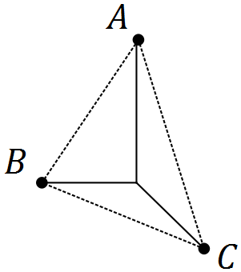
Specific behaviours
sketch with students labelled and in roughly correct positions
(No need for dimensions to be shown)

(b) Calculate the bearing of student A from student B. (2 marks)
Solution
$\tan^{-1}{\frac{60}{45}}≈53.1$
Bearing is $90-53.1≈036.9°$

Specific behaviours
calculates angle in right-triangle
states bearing

(c) Calculate the distance of student A from student C. (2 marks)
Solution
${AC}^{2}={60}^{2}+{40}^{2}-2×60×40×\cos{130}$
$AC=91.0$

Specific behaviours
uses cosine rule
calculates distance

(d) Calculate the bearing of student C from student A. (3 marks)
Solution
$\frac{40}{\sin{x}}=\frac{91.0}{\sin{130}}⇒x=19.7$

Bearing is $180-19.7=160.3°$

Specific behaviours
uses sin rule
calculates angle in triangle
determines bearing

Question 20 (7 marks)
A machine makes spherical balls of ice. A setting on the machine can change the diameter of the spheres from 1 cm up to 5 cm.

(a) Assuming that water does not change its volume as it turns into ice, determine how many 3 cm diameter spheres of ice the machine could make from 15 litres of water. (3 marks)
Hint: One litre of water takes up volume of 1 000 cm³.
Solution
$15×1000=15000$ cm³ of water

$V=\frac{4}{3}×π×{1.5}^{3}=14.14$

$15000÷14.14≈1061$ ice spheres

Specific behaviours
calculates volume of water
calculates volume of one sphere
calculates number of spheres

(b) The machine made 500 spheres of ice with a diameter of 4 cm and a worker put them all in a rectangular tray on a level table. The tray, in the shape of a rectangular prism, had a length of 62.5 cm, a width of 40 cm and a height of 12.5 cm.

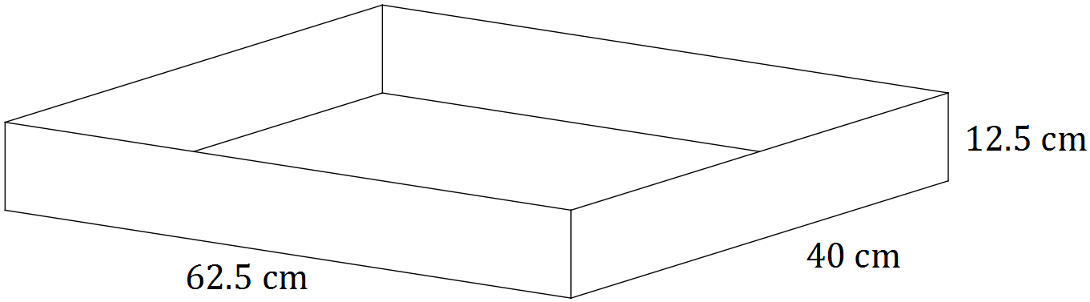

After the cubes had melted back to water, determine the depth of water in the tray.
(4 marks)
Solution
Volume of one sphere: $V=\frac{4}{3}×π×{1.5}^{3}=33.51$

Volume of all spheres: $33.51×500=16755$

Volume of prism: $16755=62.5×40×h$

Height: $h=6.7$ cm

Specific behaviours
calculates volume of one sphere
calculates volume of all spheres
uses formula for rectangular prism
calculates height

Additional working space

Question number: _________

Additional working space

Question number: _________

Additional working space

Question number: _________

© 2016 WA Exam Papers. Kennedy Baptist College has a non-exclusive licence to copy and communicate this paper for non-commercial, educational use within the school. No other copying, communication or use is permitted without the express written permission of WA Exam Papers.

